**THE WEEKLY LINK FOR** 

**Osceola United Methodist Church**

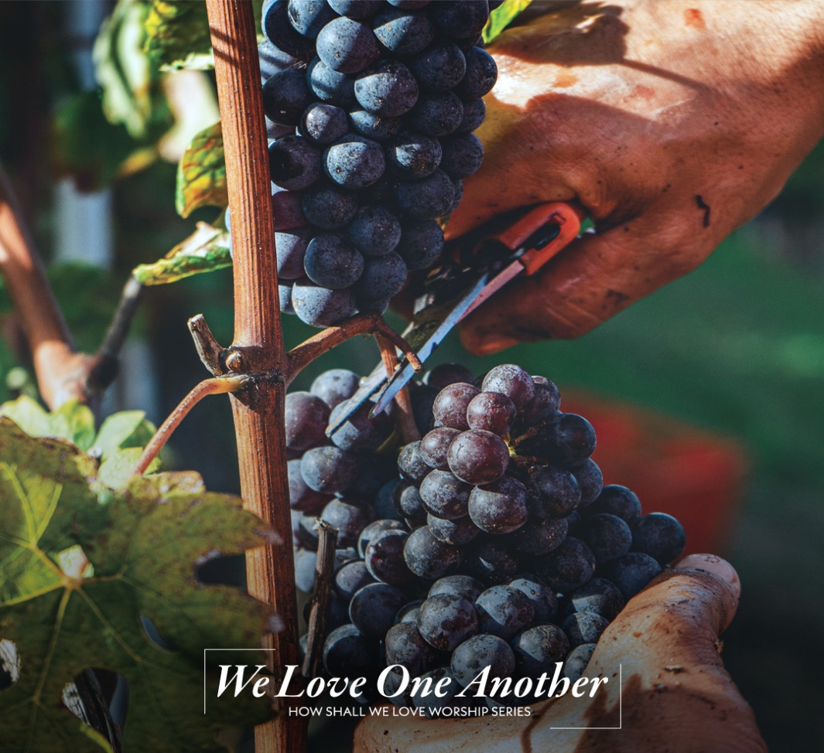**Sunday, May 5, 2024**

**10:00 am**

**one job**

The night before his death, Jesus was trying to give to those frightened followers of his, all sorts of handles for grabbing hold of life. In the midst of it, he says simply, “Just hang on to me. Stay connected to all that I was and am and will be. For the kind of life you have ahead of you, you don’t need a guidebook or a road map, you’ve got me.”

**Historic Osceola Methodist Church**

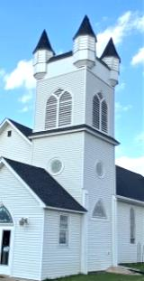306 River St., P.O. Box 447, Osceola, WI 54020

**715-755-2275 ~ Office**

[**osceolaunitedmethodistchurch@gmail.com**](mailto:osceolaunitedmethodistchurch@gmail.com)  
Website: osceolaunitedmethodistchurch.weebly.com

Facebook: United Methodist Church of Osceola WI

YouTube: Osceola United Methodist Channel  
**Rev. Jack Starr, 715-559-7522** [**starr.jack.r@gmail.com**](mailto:starr.jack.r@gmail.com)COMING UP: Worship & Other Events

Here’s our schedule looking ahead. Unless noted, all services are both IN-PERSON & ONLINE. Find them on YouTube & Facebook.

**Sunday, May 5**

**Worship with Communion 10:00 am**

**Lily’s Italian Dinner Fundraiser** (right after church)

**Tuesday, May 7**

**Trustees Meeting 6:30pm**

**=**

**Wednesday, May 8**

**Church Council 6:30pm**

**Thursday, May 9**

**Sewing Group** **1-3:00 pm**

**Service at CCHO with Communion 1:30 pm**

**Saturday, May 11**

**Church Cleaning Day 9am – 1pm**

**COMING UP**

**Sunday, May 12 Mother’s Day**

**Monday, May 13 UWF Meeting 1:00 pm**

**Wednesday, May 15 SPRC Meeting 6:30pm**

**Wednesday, May 29 Last Wednesday Meal 5:30pm**

**The church office is open** Thursday, 10am - noon

**The church building is open**

- Sunday morning for worship & prayer from 9:30 to noon

- Tuesday, 2-6 pm.

- Thursday, 10am - 1pm

**Pastor Jack’s office hours** are Tuesday, 3-5pm

And other times by appointment

**Pastor Jack’s Day of Sabbath is on Monday.**

**JOIN US ONLINE**

**Every Sunday at 10 am or at your own leisure**

Visit our Facebook Page anytime. Search Facebook For

[**United Methodist Church of Osceola WI**](https://www.facebook.com/United-Methodist-Church-of-Osceola-WI-117450971607489/?eid=ARATw0gInrdmB9gCvbtlxniYWAmZ92qq91daFpBpzBELGLO5b2H4JDj6VFPuCxO7a-8UwXPEp8Yj3BxP)

Or our**[Osceola United Methodist Channel](https://www.youtube.com/channel/UCM69J3Rem-f16St9Hv85p_w)**

Get here more easily: subscribe to our YouTube channel

**Sunday May 5, 2024**

**THIS MORNING’S ORDER OF SERVICE**

**PRELUDE** Cheryl Hustad

**WORDS OF WELCOME** Ringing the Church Bell

**CALL TO WORSHIP**

LEADER: Hear O People, Jesus chose you and calls you friend!

**PEOPLE: We abide in Christ because Christ abides in us.**

LEADER: Jesus made a home among us to show us how to love.

**PEOPLE: We abide in Love because Love abides in us.**

LEADER: Jesus invites us to come to the Table to know the joy that comes when we love one another the way God loves us.

**PEOPLE: We abide in Joy because Joy abides with us.**

LEADER: Beloved of Christ. Jesus welcomes you home!

**ALL: We come to make our home with God & one another, bound together by Love and enlivened by Joy. Amen.**

**OPENING HYMN** *(please stand as you are able)*

***Come, Christians, Join to Sing UMH 158***

*1 Come, Christians, join to sing Alleluia! Amen!  
loud praise to Christ our King; Alleluia! Amen!  
let all, with heart and voice, before his throne rejoice;  
praise is his gracious choice. Alleluia! Amen!*

*2 Come, lift your hearts on high, Alleluia! Amen!  
Let praises fill the sky; Alleluia! Amen!  
He is our Guide and Friend; to us he’ll condescend;  
his love shall never end. Alleluia! Amen!*

*3 Praise yet the Lord again, Alleluia! Amen!  
Life shall not end the strain; Alleluia! Amen!  
On heaven’s blissful shore, his goodness we’ll adore,  
singing forevermore, Alleluia! Amen!*

**OPENING PRAYER**

Gracious creator. We, who so often take the wonders of creation for granted, welcome the opportunity to make a joyful noise before you, O God. We come here this morning to worship and to praise you. But joyful noises are not easy for everyone to make. Some are burdened down with the stresses of daily living; some wearied from tasks of serving others; some worried over the state of the world. Some live in want and fear. Speak to us all, O God, in the stillness of this time and remind us of Jesus’ willingness to take our burdens upon himself. Teach us to learn from him - to experience his gentleness and steadfast love for all, and especially to know his joy so that our joy might be complete. We offer this time of worship to you, O God, praying that it may reflect our praise & thanksgiving for the gifts of creation and for all that Jesus has done for us. This we pray in his name. **Amen.**

**RESPONSIVE READING**

**PSALM 98** UMH PSALTER pg 818

LEADER: O sing to the Lord a new song, for the Lord has done marvelous things. God’s right hand and holy arm have gotten the victory.

**PEOPLE: The Lord has declared victory; and has revealed his vindication in the sight of the nations.**

LEADER: The Lord has remembered his steadfast love and faithfulness to the house of Israel.

**PEOPLE: All the ends of the earth have seen the victory of our God.**

LEADER: Make a joyful noise to the Lord, all the earth,

**PEOPLE: break forth into joyous song and sing praises.**

LEADER: Sing praises to the Lord with the lyre, with the lyre and the sound of melody.

**PEOPLE: With trumpets and the sound of the horn  
make a joyful noise before the Ruler, the Lord!**

LEADER: **7**Let the sea roar, and all that fills it; the world and those who dwell in it.

**PEOPLE: Let the floods clap their hands; let the hills sing for joy together before the Lord, who comes to judge the earth.**

**ALL: The Lord will judge the world with righteousness, and the peoples with equity.**

**EPISTLE LESSON**

***1 John 4:7-12 CEB***

**7**Dear friends, let’s love each other, because love is from God, and everyone who loves is born from God and knows God. **8**The person who doesn’t love does not know God, because God is love. **9**This is how the love of God is revealed to us: God has sent his only Son into the world so that we can live through him. **10**This is love: it is not that we loved God but that he loved us and sent his Son as the sacrifice that deals with our sins. **11**Dear friends, if God loved us this way, we also ought to love each other. **12**No one has ever seen God. If we love each other, God remains in us and his love is made perfect in us.

**GOSPEL LESSON**

***John 15:5, 8, 9-17 CEB***

**5**I am the vine; you are the branches. If you remain in me and I in you, then you will produce much fruit. Without me, you can’t do anything…..  **8**My Father is glorified when you produce much fruit and in this way prove that you are my disciples.

**9**“As the Father loved me, I too have loved you. Remain in my love. **10**If you keep my commandments, you will remain in my love, just as I kept my Father’s commandments and remain in his love. **11**I have said these things to you so that my joy will be in you and your joy will be complete. **12**This is my commandment: love each other just as I have loved you. **13**No one has greater love than to give up one’s life for one’s friends. **14**You are my friends if you do what I command you. **15**I don’t call you servants any longer, because servants don’t know what their master is doing. Instead, I call you friends, because everything I heard from my Father I have made known to you. **16**You didn’t choose me, but I chose you and appointed you so that you could go and produce fruit and so that your fruit could last. As a result, whatever you ask the Father in my name, he will give you. **17**I give you these commandments so that you can love each other

LEADER: May God bless the hearing and understanding of this portion of scripture.

**PEOPLE: Thanks be to God.**

**A REFLECTION ON GOD’S WORD**

When you read some of the warning labels posted on products, have you ever thought, “Who did what to warrant clarifying that?”

.A fold up stroller had “Caution: Remove infant before folding for storage." And a clothes iron had "Do not iron clothes on body." Still there is plenty of evidence that human beings seem to struggle with common sense, distraction or just plain incompetence. There is a funny meme going around on the internet with the theme ‘You Had One Job’ showing pictures of professional failures – doors opening into midair, stairs leading nowhere, misspelled stop signs.

One Job. In John 15, as Jesus shares some final teaching with his disciples, he very clearly tells us that we, as branches connected to the Vine, are called to bear fruit. Most us have heard this phrase a few times - bear fruit – and may think we know what it means. Some might have no idea what it means. What does it mean for Christians to bear fruit? As Jesus continued his discourse (this section of John is sometimes called a *farewell discourse*) he began to unpack that for his disciples, and for us.

“Stay connected to all that I was and am and will be.” He says, “Remember my example; sense my ongoing presence.” He talks about obedience: “keep my commandments” and sacrifice: “there is no greater love than to lay down one’s life for one’s friends”. He talks about love a lot. Perhaps in the business of bearing fruit, that is the ‘one job’. And right in the middle of it, he talks about joy; about his joy and about our joy being complete. And that makes it worth taking a little time to think about it.

Eternal joy is a gift that comes from Jesus – from abiding in him. He says that to abide in him is to obey his commandment to love one another as he loved us – to love as he loves. It is to look outward. Joy is found not in the contentment of satisfying our own desires, but in service to those we love as he loves. It is in acts of service; it is in healing and helping; it is in holding shaky hands and calming troubled hearts; it is in honoring those we love. As you might remember from that old folk song by Malvina Reynolds,

*Love is something if you give it away, give it away, give it away.  
Love is something if you give it away; You end up having more.*

Because love isn’t even love until we give it away.

The full text of Jack’s message is available at the church office

**SPECIAL MUSIC FOR REFLECTION** *Cheryl & Ensemble*

***God Bless to Us Our Bread***

*God bless to us our bread,*

*And give bread to those who are hungry,*

*And hunger for justice to those who are fed.*

*God bless to us our bread.*

**THE PRAYERS OF GOD’S PEOPLE**

As we pray you are invited to lift up those whose names are in your heart. You’re invited to share prayers out loud or online & we will respond to affirm our participation in that prayer.

LEADER: Lord in your love…

**ALL: Hear this, our prayer.**

**LORD’S PRAYER UMH 895**

**Our Father who art in Heaven, hallowed be thy name. Thy kingdom come, Thy will be done on earth, as it is in heaven. Give us this day our daily bread. And forgive us our trespasses as we forgive those who trespass against us. Lead us not into temptation but deliver us from evil. For Thine is the kingdom and the power and the glory forever. Amen**

**COMMUNION HYMN** *(please stand if you are comfortable)*

***All Who Hunger TFWS 2126***

*All who hunger gather gladly; holy manna is our bread.  
Come from wilderness and wand’ring. Here in truth we will be fed.  
You that yearn for days of fullness, all around us is our food.  
Taste and see the grace eternal. Taste and see that God is good.*

*All who hunger, never strangers; seeker, be a welcome guest.  
Come from restlessness and roaming. Here in joy we keep the feast.  
We that once were lost & scattered in communion’s love have stood.  
Taste and see the grace eternal. Taste and see that God is good.*

*All who hunger, sing together, Jesus Christ is living bread.  
Come from loneliness and longing. Here in peace we have been fed.  
Blest are those who from this table live their days in gratitude.  
Taste and see the grace eternal. Taste and see that God is good.*

**THE LORD’S TABLE**

Christ our Lord invites to his table all who love him, who earnestly repent of their sin and seek to live in peace with one another. Therefore, let us confess our sin before God and one another.

**CONFESSION AND PARDON.**

**Almighty God, you love us, but we have not loved you; you call, but we have not listened. We walk away from neighbors in need, wrapped up in our own concerns. We have gone along with evil, with pride, quarrelling, and divisiveness. Holy God, help us to face up to ourselves, so that, as you move toward us in mercy, we may repent, turn to you, and receive mercy; through Jesus Christ our Lord. Amen.**

Hear the Good News! God so loved the world that he gave his only son that whoever turns to him will never perish. Jesus didn’t come to condemn us but that we might have life. This proves God's love toward us! In the name of Jesus Christ, you are forgiven!

**In the name of Jesus Christ, you are forgiven!**

**Glory to God! Amen.**

**PRAYER OF DEDICATION FOR OUR GIFTS**

*We give thanks for God’s blessings & dedicate our gifts to God’s work.*

**God of joy, we offer our gifts this day, as we reflect on the wisdom of your Word. Jesus urges us to hold onto him, to stay connected to his example, presence, and the fulfillment he brings. He reveals that our joy finds completeness when it is woven into his divine joy. Help us abide in him through love, obeying his commandment to love one another. In acts of service, healing, and selfless generosity, may our joy be sustained, a shared and everlasting gift from the source of all joy. In Jesus' name, we pray. Amen**

**THE GREAT THANKSGIVING**

The Lord be with you. **And also with you.**  
Lift up your hearts. **We lift them up to the Lord.**  
Let us give thanks to the Lord our God.  
**It is right to give our thanks and praise.**

It is right, and a good and joyful thing, always and everywhere to give thanks to you, God of vision, creator of all things; heaven & earth, land & sea, light and darkness. You formed us in your image and breathed into us the breath of life. You made us for love and joy and fellowship. When we failed at that you stubbornly refused to give up on us.. And so, with your people on earth and all the company of heaven we praise your name and join their unending hymn:

**Holy, holy, holy Lord, God of power and might,** **heaven and earth are full of your glory.** **Hosanna in the highest.** **Blessed is he who comes in the name of the Lord.** **Hosanna in the highest.**

You continued to reveal your love for us in your child, Jesus,  
who came to live among us as a human being on this Earth.  
When dining with friends, just before his ordeal, Jesus reminded them of your love revealed in the gifts of bread and juice before them on the table. Jesus took the bread, gave thanks to you, broke it, and shared it with those friends, saying the words we know so well, “Take, eat. This is my body which is given for you; do this in remembrance of me.” And when the supper was over, Jesus took the cup, again gave thanks for it, and shared it with all who gathered, reminding them, “Drink this all of you. This is the cup of my covenant with you, for the forgiveness of sins. Do this, as often as you drink it, in remembrance of me.”

And so, Together we proclaim the mystery of faith.

**Christ has died; Christ is risen; Christ will come again.**

Pour out your Holy Spirit on us gathered here and on these gifts of bread and wine. Make them be for us the body and blood of Christ, that we may be for the world the body of Christ redeemed by His blood. By your Spirit make us one with Christ, one with each other, and one in ministry to all the world. **Amen**

**Taking the Bread and the Cup**

*In the United Methodist Church, we celebrate “open communion.”*

*All are welcome to receive God’s gifts of bread and cup, love and life. We invite you to come forward today to receive the elements.*

*If you are joining us online we invite you to use your own elements of bread and beverage and join us by saying as you take them.*This is the body of Christ, given for us.   
This is the blood of Christ, the cup of new life, given for us.

**PRAYER AFTER RECEIVING** (*Written by Rev. Laura Baumgartner*)

**Creative God, we thank you for revealing your love to us in bread and juice. We recognize your presence in us and all around us, and we ask that you continue to reveal your love for all Creation to the ends of the Earth through our lives. Make us your people and use us to reveal the inbreaking of your kingdom here and now: a world of justice and peace. Amen.**

**ANNOUNCEMENTS**

**BENEDICTION**

**Beloved Family, may God bless us with the strength to love one another as God loves each and every one of us, that we may find the complete, total, and everlasting joy that comes when we abide together with God who is Love. Amen.**

**RESPONSE**

***Let There Be Peace on Earth UMH 431***

*Let there be peace on earth, and let it begin with me;*

*Let there be peace on earth, the peace that was meant to be.*

*With God our creator, children all are we.*

*Let us walk with each other in perfect harmony.*

*Let peace begin with me; let this be the moment now.*

*With every step I take, let this be my solemn vow:*

*To take each moment and live each moment in peace eternally.*

*Let there be peace on earth, and let it begin with me.*

**POSTLUDE***Cheryl Hustad*

**Leaders for today’s service**

**Music Service:** Cheryl Hustad

**Message:** Jack Starr

**Flowers This Week:** Ann Layton

**Tech Help:** Mark Koeller

**Greeters This Week:** Richard Kretzschmar

**Fellowship Host:** Italian Dinner Fundraiser

**THE WEEKLY LINK**

**Church Update for May 5, 2024**



**Saturday, May 11** **9am – 1pm**

**Spring Clean-Up**

**CAN YOU LEND A HAND?**

**Spring Tasks include:**

Rake the Yard & Clean out the Gardens

Prep Mower for Summer

Set Up Patio Tables

Clean Sidewalks and Curbs

Clean Windows

Cut wood & brush

**WE NEED BREAKFAST WORKERS June 10**

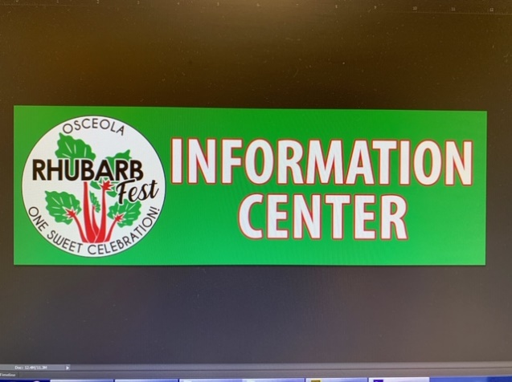Our church has been asked to host a free pancake breakfast to kick off a day of festivities for the Osceola Rhubarb Fest on **Saturday, June 10**. We serve from 9 until 11:30 a.m. on that day.

We need people to work all areas and **we need a coordinator**. We had a great time doing it in the past. Ready to do it again? **There’s a signup sheet on the Greeter’s Table.**

**A NEW STUDY/DISCUSSION GROUP**

Would you like to be a part of a ***Companions in Christ*** group?

You still have a change to join. It will begin in June.

The *Companions in Christ* series has helped people become open to God's presence and guidance in deep and meaningful ways. Together, we will explore classic spiritual practices and develop new daily habits that deepen your relationship with God and with each other.  Facilitator: Richard Kretzschmar

Up your RECYCLING Game

There are more things that can be recycled than you think. Have you been saving items to be recycled? We’ll collect them and take them to TERRACYCLE

SOME EASY SAVES….

* Old toothbrushes, dental floss containers, heads from electric toothbrushes
* Clean Styrofoam meat trays
* Old pens, pencils, dried up markers, used glue sticks.
* **A logo with text on it

  Description automatically generated**Empty cereal bags

JUST THINK…if we each saved 2 old toothbrushes, that would be 100 toothbrushes NOT sitting in a landfill.

If you have any of the above items that you would like to bring in, there is an empty box in the fellowship hall for you to place your items. The United Women in Faith already delivered some on April 27th**,** we are continuing with this project. Doing our part for creation is always timely.

**“SMALL CHANGES CAN HAVE A BIG IMPACT.”**

**Meanwhile, KEEP UP YOUR SOCK DONATIONS**

We delivered a large bag of socks last Saturday (and as you can see, so did many other churches)! All socks are welcomed (mismatched, worn out, even “holy” ones). United Women in Faith units will box the socks and send them to be recycled. For each box we fill, we will earn a small $ donation that will be designated for Northcott Neighborhood House in Milwaukee. Place your socks in the brown laundry basket in the fellowship hall. Let’s continue with this.

Missions Update

**TODAY!!! Join us for a Spaghetti Dinner right after church!**

LILY KNE IS GOING TO ITALY ON A SCHOOL TRIP and we want to help her get there. Lily is one of our confirmands. She started raising money for this trip last summer when she made jewelry & sold it at our Farmer’s Market. She has been determined to earn this money on her own, and has done a great job…let’s help her earn that last little bit. **Join us for spaghetti, salad, garlic toast & Italian ice TODAY right after church. This is a free will donation event. All are invited!**

Our Church’s Easter & Lenten Missions

We’ve had an active season of giving for our Lenten/Easter mission offering and we are blessed to be able to report these numbers for the season.

GOOD NEWS! Our Easter “Giving from Abundance” offering helped us buy **100 blankets** through Church World Service (CWS)!

The other part of our Lent & Easter offering was sent to **Northcott Neighborhood House in Milwaukee…$930.30**!! Thank you to all who participated in this Mission…you have made a difference in someone’s life.

**THE BACKPACK PROGRAM** Open Cupboard’s “Backpack Program” is a food distribution program that sends backpacks full of kid-friendly food home each weekend to families that might need a little extra. **THIS IS THE LAST MONTH FOR THIS SCHOOL YEAR.** Let’s finish in a big way! Our church is providing oatmeal & tuna (cans or individual packets). Money can also be designated “Backpack Program.” Thanks for your ongoing support!

**The 2020 United Methodist General Conference is being held right now, April 23 - May 3, 2024, in Charlotte, North Carolina.**

Here are some of the things going on.

The 2024 General Conference has nearly 900 delegates overall, equally split between clergy and laity. Of the 2024 delegates, 55.9% will be from the U.S., 32% from Africa, 6% from the Philippines, 4.6% from Europe and the remainder from concordat churches that have close ties to The United Methodist Church.

The 2024 General Conference has nearly 900 delegates overall,

From Wisconsin there a number of people representing us. Some as delegates, others as observers and others who are serving. During the 2019 Annual Conference, three clergy and three laity were elected to serve as voting delegates to General Conference and three clergy and three laity were elected to serve as voting delegates to the North Central Jurisdictional Conference. Jurisdictional Conferences are regional conferences that meet every 2 years and among other things they elect and appoint Bishops.

**General Conference**

**Lay Delegates**

Lisa King  
Jessica Gobel  
Lisa Jones

**Clergy Delegates**

Rev. Jenny Arneson  
Rev. Krysta Deede  
Rev. Allie Scott

**Jurisdictional Conference**

**Lay Delegates**

Donald Cramer  
Meredith Spors  
Gail Burgess

**Clergy Delegates**

Rev. Kate Croskery Jones  
Rev. Jeremy Deaner  
Rev. Scott Carlson

Before the conference began A group of U.S. delegates has a statement on three major legislative proposals that many of us hope to see passed at General Conference. Now in the 2nd week of the conference we have seen most of these proposals adopted.

**THE THREE Rs**

[**Worldwide Regionalization**](https://www.resourceumc.org/en/churchwide/the-connectional-table/regionalization-legislation)**,** a plan that aims to put the different regions of the denomination on equal footing. The proposal would create eight distinct regional governing bodies in what are currently the seven central conferences in Africa, Europe, the Philippines as well as in the United States. Each region would have the same authority to adapt portions of the Book of Discipline. This **requires amending the denomination’s constitution**. For ratification, an amendment must receive at least a **two-thirds vote** at General Conference and at least a two-thirds total vote at annual conferences. Most other legislation requires a simple majority. The legislation allows for greater self-determination & self-governance in the world UMC. This proposal was passed last week and now faces ratification at the annual conferences

[**Revised Social Principles**](https://www.umcjustice.org/who-we-are/proposed-revised-social-principles-for-general-conference-charlotte)**,** There were many petitions that revise the denomination’s social witness as stated in our Book of Discipline with United Methodists from around the globe contributing to the revisions. While this isn’t the only issue in question, this issue LGBTQ inclusion has the highest profile. This revision is that our Discipline makes no reference to homosexuality at all. Since 1972, the Social Principles have stated that “the practice of homosexuality… is incompatible with Christian teaching.” Most of these changes have already passed.

**Removal of Exclusionary Language.** There are statements of policy against full inclusion of LGBTQ people. Since General Conference added the Social Principle on homosexuality in 1972, [subsequent gatherings have added bans](https://www.umnews.org/en/news/gc2016-tackling-44-year-stance-on-homosexuality-new-2022) on “self-avowed practicing” gay clergy and the officiation of same-sex weddings. Also since 1972, every General Conference has been marked by rancorous debate over the place of LGBTQ people in church life. The clashes culminated in the special 2019 General Conference, which passed the Traditional Plan that aimed to strengthen enforcement of the bans and opened the door for the church disaffiliations seen over the past four years. This returns the Book of Discipline to where it was from 1784 to 1972, and removes the cause of so much of our friction and division for the last 50 years, This was passed this week with 93% of the delegates in approval and will take place immediately.

You can find out a little bit more about this all for yourself. There are handouts in the fellowship hall near the counter to the kitchen.

**United Women in Faith News**

**Luncheon at the Pizzaria.**

ALL women of the church to the UWFaith meeting at Pizzeria on **May 13 at 1:00.** Even if they are not members, they are welcome to join us for a time of fun and sisterhood.

**\*There will be NO May Baskets this year. If you have made candy in the past or bought it, they are asking for donations. See Norma or Sue S. They hope to contribute candy at the Farmer’s Market.**

Our regular meeting is at 1pm on the 2nd Monday of the month.

All women are invited.

**Please Remember in Prayer**

The United Methodist General Conference going on now.

The people of Israel and Gaza, especially the hostages & refugees   
and the medical workers & aid workers. • The people of Ukraine • Those affected by the tornadoes and severe weather • Citizens of Mount Horeb •  
• The border crisis • Our LGBTQ siblings in Christ •

Victims of violence especially shooting victims & victims of hate crimes

The unrest on our college campuses; that all voices are heard.

**Family & friends struggling with issues of uncertainty, fear & loss,**

• Lindsay & Penelope • Karen’s family • Dan’s friend Travis and children •

•Stephanie’s family• Amber and her boys • Carol • Ginny • Basham Family

• Students contemplating suicide • Roger • Zach • Kathy • Emily • Jessica • Ivan

• Donna’s son • Hannah’s family • Bob’s Family & Friends • Aaron • Wayne & Sue

**People with illness, procedures, recovery & other health issues:**

• Maren Starr • Solomon • Karin & Tony • Fern’s sister, Jean • Dale • Dee •

Lance • Carol• Brittany • Mark • Cheri & Ron • Nora • Joan • John • Eve • Louise

• Sarah’s brother & family • Alma • Brian • Tom Steller • Sarah C • Kurt • Randy Schock •. Donna’s friend Kathy • Carol’s sister, Mary • Rod’s Aunt Delores

• Betty Schandorff • Liz’s friend Sondra • Terry • Dean • Bill • Kris • Shannon

• Laurelei’s son, Walter and daughter, Andrea • Ron & Cheri’s son • David’s sister

**HAPPY BIRTHDAY**

May 31 Mike Alaimo

May 31 Bob Olson

**HAPPY ANNIVERSARY**

May 4 Jim & Rhonda Dunham

May 18 Steve & Doreen Snell

**MUSICIANS FOR MAY**

May 5 Cheryl Hustad

May 12 Norma Kretzschmar

May 19 Maritsa Hristova & James Rosamilia

May 26 Maritsa Hristova & James Rosamilia

**FELLOWSHIP HOSTS FOR May**

May 5 Italian Dinner Fundraiser

May 12 Sue & Allen Carlson

May 19 Janice Etsinger & Sue Carlson

May 26 Shirley & Jim Hermanek

**Covid Protocol for Osceola UMC**

Each week Osceola UMC determines our Covid risk level along with masking, social distancing, & other recommendations based on cases in Polk, St. Croix, Chisago & Washington counties in WI and MN.

According to the latest update from the CDC in our area,

for the week of MAY 5, the danger is **LOW**



**Osceola United Methodist Church**

**P.O. Box 447**

**306 River St.**

**Osceola, WI 54020**

***Sunday Morning Worship at 10 a.m.***

